

UNDERGRADUATE PROJECT PROPOSAL

|  |  |
| --- | --- |
| **Project Title:** | **Sequential Recommendations with Graph Neural Networks** |
| **Surname:** | **Anju** |
| **First Name:** | **Chen** |
| **Student Number:** | **202118010227** |
| **Supervisor Name:** | **Joojo Walker** |
| **Module Code:** | **CHC 6096** |
| **Module Name:** | **Project** |
| **Date Submitted:** | **2024.11.04** |

**Table of Contents**

1 Introduction 3

1.1 Background 3

1.2 Aim 3

1.3 Objectives 3

1.4 Project Overview 3

1.4.1 Scope 4

1.4.2 Audience 4

2 Background Review 5

3 Methodology 6

3.1 Approach 6

3.2 Technology 7

3.3 Version management plan 7

4 Project Management 7

4.1 Activities 7

4.2 Schedule 9

4.3 Data management plan 9

4.4 Project Deliverables 9

5 References 9

# 

# Introduction

## Background

As digital media and e-commerce gain prominence, individuals encounter an ever-expanding volume of information, rendering personalised recommendation systems particularly vital. Recommender systems assist consumers in sifting through extensive information to identify engaging material, while simultaneously enabling content suppliers to enhance their services, thereby elevating user happiness and commercial value. Graph neural networks (GNNs), as an innovative technological approach, exhibit significant potential in the analysis of intricate relational data, particularly in the examination of user behaviour sequence data.

## Aim

This project aims to explore how graph neural networks can be used to build efficient and accurate sequential recommendation systems. The goal is to develop an effective way to capture user behavior patterns and make accurate recommendations based on them.

## Objectives

The objectives of this project encompass, but are not restricted to:

1.Analysing the existing literature, databases, and technical solutions pertaining to sequence suggestion  
2. Design and execute a sequential recommendation system utilising graph neural networks.   
3. Assess the efficacy of the suggested algorithm and enhance its prediction capability;

4.Validate the algorithm's practical usefulness and gather feedback from end users.

## Project Overview

This research focusses on employing graph neural network methodologies to enhance the efficacy of recommender systems. By precisely detecting consumers' interests and preferences, recommender systems may deliver more tailored services. This is a significant advancement for service providers dependent on user engagement and retention. This proposal will include the background, methodology, management, and execution plan of the project.

### Scope

This research aims to use graph neural networks to build efficient sequential recommendation systems to improve recommendation accuracy and user experience. The importance of this research is to reduce the time for users to find interested content, attract more users, and promote the wide application of recommendation systems in many fields.

### Audience

Beneficiary Groups:

This research aims to develop an efficient sequential recommendation system using Graph neural networks (GNNs) to improve recommendation accuracy and user satisfaction. The results will directly benefit content providers and service platforms, such as e-commerce sites, social media platforms, and video-on-demand services, which will be able to use more accurate recommendation algorithms to attract and retain users, thereby enhancing user engagement and increasing business returns. In addition, advertisers and marketers benefit because they can target their audience more effectively and achieve more precise marketing strategies.

Target Audience:

The target audience mainly includes technology developers, researchers, and business decision makers. For technology developers, the methods and tools provided in this study will help them integrate advanced recommendation functions into existing systems. For researchers, this study will contribute to the academic community's understanding and development of the application of graph neural networks in recommender systems. Finally, business decision makers will be able to develop more effective business strategies and increase market competitiveness by applying the results of this study. In conclusion, any business and individual relying on user interaction and personalized experience enhancement will benefit from the findings of this study.

# Background Review

## Background Review of Sequential Recommendations

Sequential recommendation is a critical task aimed at predicting the next item a user might interact with based on their historical interaction sequences[11]. Another approach involves integrating group behaviors to enhance the modeling of user preferences through collective wisdom[5].Furthermore, sequential recommendation models have evolved to consider multi-dimensional transformations between items[3] and to alleviate the negative impact of data sparsity[2]. Sequential recommendation models have also benefited from the integration of heterogeneous information such as category and time information[3], and the exploration of deep user interests [1].

## 2.2 Background Review of Graph Neural Networks

Graph Neural Networks (GNNs) have been pivotal in improving recommendation systems by capturing the complex relationships within user-item interactions[7]. In session-based recommendation, GNNs have been utilized to capture complex transitions of items [8]. The Graph Contextualized Self-Attention Network (GC-SAN)[9] further enhances this by dynamically constructing a graph structure for session sequences and capturing rich local dependencies via a graph neural network.These advancements highlight the versatility and effectiveness of GNNs in recommendation systems, from simplifying architectures[4] to integrating complex multi-dimensional transformations[3] and leveraging heterogeneous information[10]. The continued development of GNN-based methods promises to further enhance the accuracy and relevance of recommendations in various domains.

# Methodology

## Approach

Sequential recommendation with Graph Neural Networks (GNNs) is grounded in representing user-item interactions as graph structures. Nodes represent users and items, and edges signify interactions. Mathematically, the embeddings of items are updated through layers of graph convolutions, which propagate embeddings based on the graph structure:

$$E^{(l+1)}=σ(D^{−\frac{1}{2}}AD^{−\frac{1}{2}}E^{(l)}W^{(l)})$$

Here,E (ℓ) is the embedding matrix at layer ℓ, W (ℓ)is a trainable weight matrix, and σ is a non-linear activation function. This iterative process captures the influence of neighboring nodes on each item.

To prevent overfitting, dropout techniques are applied, typically setting a dropout rate of around 0.2. Attention mechanisms, such as self-attention, prioritize the most relevant items in a user's interaction history. Residual connections are used to help gradients flow through deeper layers, aiding in the training of more complex models.

The assessment of GNN-based sequential recommendation models is performed using datasets such as MovieLens, Steam, UserBehavior, and others. These datasets document user-item interactions together with their corresponding timestamps.

Preprocessing includes cleaning data, encoding temporal information, and splitting data into training, validation, and test sets. A common evaluation method is the leave-one-out approach, where the last item in a sequence is used for testing the model's prediction accuracy.

## Technology

The technologies used to implement the projects are:

|  |  |  |
| --- | --- | --- |
| **Type** | **Working area** | **Actions** |
| Software | Development environment and core libraries | Python(3.12), PyTorch(1.7) |
| Data processing and analysis | NumPy(1.16), Pandas(0.24) |
| Scientific Computing and Machine Learning | Scikit-Learn(0.2), SciPy(1.1) |
| Visualization tools | Matplotlib(3.0), TensorBoard(2.0) |
| Hardware | CPU | AMD Ryzen 5 5800H with Radeon Graphics |
| GPU | NVIDIA GeForce RTX 3060 Laptop GPU 4G |
| Memory | Kingston DDR4 3200MHz 16G |

Table 1: Technologies used for product

## Version management plan

There will be two main versions expected. Each version will be stored in the Git

repository with the help of GitHub and backup in Baidu Cloud.

# Project Management

## Activities

|  |  |
| --- | --- |
| **Objectives** | **Actions** |
| a. Review the current literature, databases, and technical schemes in the field of sequence recommendation | Collect the latest research papers on sequence recommendation within the last 5 years, especially those using deep learning methods. |
| Analyzes the current mainstream sequential recommendation models, and records their advantages and disadvantages. |
| Explore existing publicly available datasets for training and testing recommender systems. |
| Examine open source frameworks and technology stacks as well as specific graph processing libraries. |
| b. Designs and implements a sequential recommendation algorithm based on graph neural network | Define the core components of the algorithm, including how to build the user-item interaction graph and how to apply GNNS on the graph. |
| To implement the algorithm prototype, start with a simple GNN architecture and gradually increase the complexity. |
| Preliminary models are trained on selected datasets and key parameter adjustments during training are recorded. |
| Use version control to manage code updates and iterations. |
| c. Evaluate the performance of the proposed algorithm and optimize its predictive ability | Standard evaluation metrics are used to measure recommendation accuracy. |
| Cross-validation was performed to determine the best hyperparameter Settings |
| The model is regularized to prevent overfitting and an early stopping strategy is used. |
| Experiment with different combinations of loss functions and optimizers to find the most efficient configuration. |
| d. To verify the practical application effect of the algorithm, and collect the feedback of end users | Deploying recommender systems in the real world. |
| An A/B test is designed to compare the performance difference between the new algorithm and the existing recommender systems. |
| Investigate the end user satisfaction with the recommendation results |
| The algorithm is further adjusted based on user feedback and how these improvements affect the user experience is documented. |

Table 2 : Activities table

## Schedule

Below is the schedule of this project, the schedule starts at October 28th 2024 and end at

March 27th 2025.

The Gantt graph was shown below:

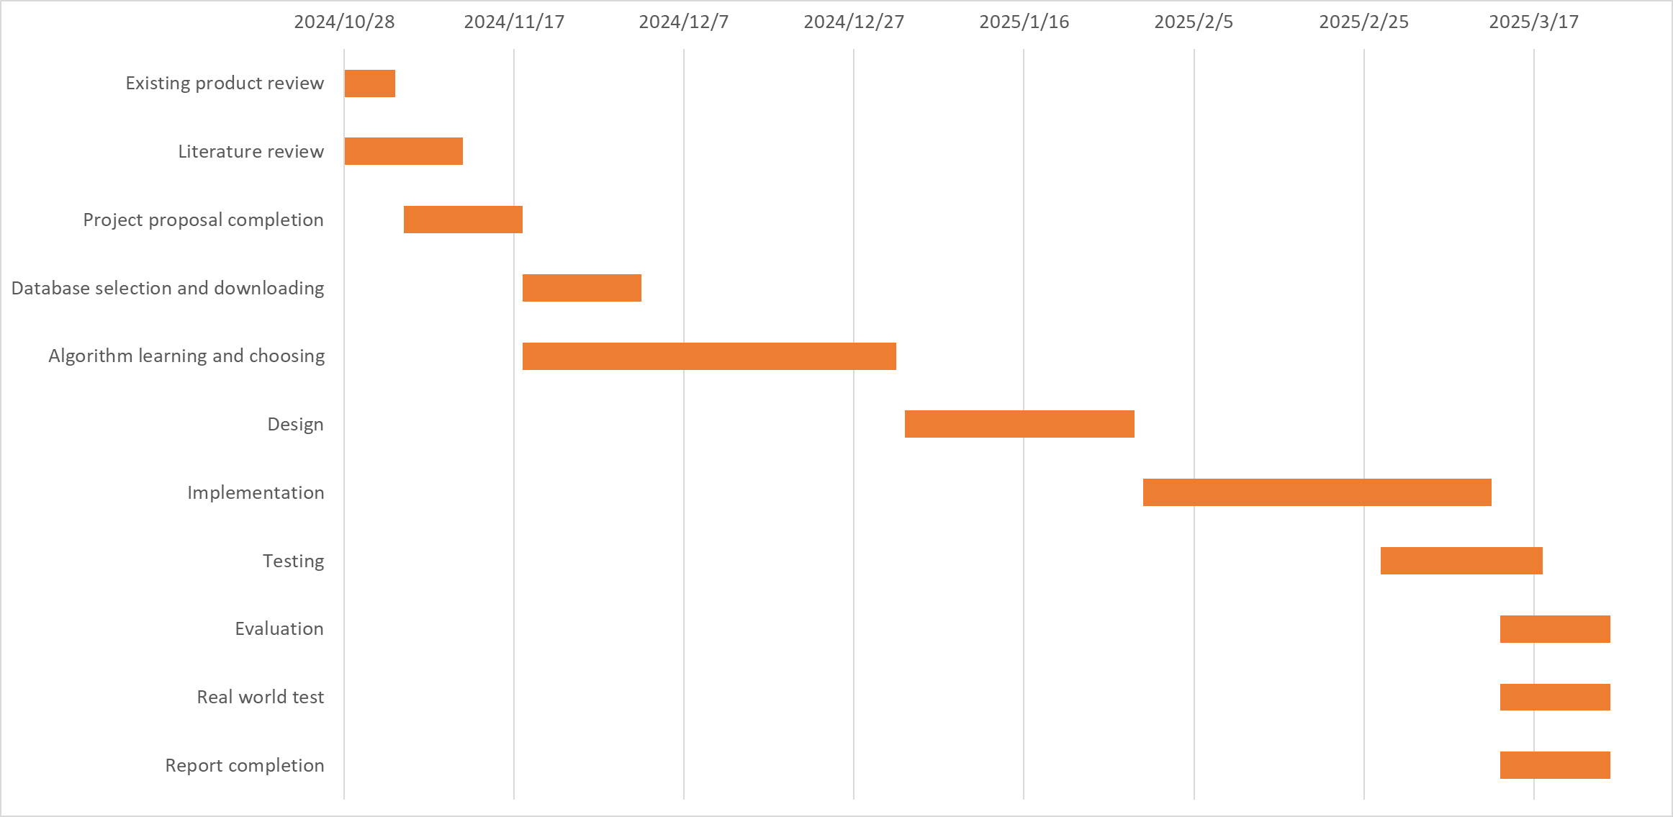

Figure 1: Gantt chart of the schedule

## Data management plan

All project logs, reports and literature generated by this project will be saved in Baidu online disk, and each version will be numbered and iterated. Baidu online desk link: <https://pan.baidu.com/s/1DMeNeMMzVC4IXmbEU8ETYA?pwd=ckjk>

## Project Deliverables

There are in total 5 deliverables, the project proposal, the progress report, final report,

presentation files and the project code.

# References

[1] Chen, Junyang, Jingcai Guo, Qin Zhang, Kaishun Wu, Liangjie Zhang, Victor C.M. Leung, Huan Wang, and Zhiguo Gong. ‘Unveiling User Interests: A Deep User Interest Exploration Network for Sequential Location Recommendation’. *Information Sciences* 689 (January 2025): 121416. <https://doi.org/10.1016/j.ins.2024.121416>.

[2] Chen, Ruixin, Jianping Fan, and Meiqin Wu. ‘MC-RGN: Residual Graph Neural Networks Based on Markov Chain for Sequential Recommendation’. *Information Processing & Management* 60, no. 6 (November 2023): 103519. <https://doi.org/10.1016/j.ipm.2023.103519>.

[3] Hao, Yongjing, Jun Ma, Pengpeng Zhao, Guanfeng Liu, Xuefeng Xian, Lei Zhao, and Victor S. Sheng. ‘Multi-Dimensional Graph Neural Network for Sequential Recommendation’. *Pattern Recognition* 139 (July 2023): 109504. <https://doi.org/10.1016/j.patcog.2023.109504>.

[4] He, Xiangnan, Kuan Deng, Xiang Wang, Yan Li, Yongdong Zhang, and Meng Wang. ‘LightGCN: Simplifying and Powering Graph Convolution Network for Recommendation’. arXiv, 7 July 2020. <http://arxiv.org/abs/2002.02126>.

[5] Huang, Zhen, Zhongchuan Sun, Jiaming Liu, and Yangdong Ye. ‘Group-Aware Graph Neural Networks for Sequential Recommendation’. *Information Sciences* 670 (June 2024): 120623. <https://doi.org/10.1016/j.ins.2024.120623>.

[6] Li, Xiao, Li Sun, Mengjie Ling, and Yan Peng. ‘A Survey of Graph Neural Network Based Recommendation in Social Networks’. *Neurocomputing* 549 (September 2023): 126441. <https://doi.org/10.1016/j.neucom.2023.126441>.

[7] Wang, Xiang, Xiangnan He, Meng Wang, Fuli Feng, and Tat-Seng Chua. ‘Neural Graph Collaborative Filtering’. In *Proceedings of the 42nd International ACM SIGIR Conference on Research and Development in Information Retrieval*, 165–74, 2019. <https://doi.org/10.1145/3331184.3331267>.

[8] Wu, Shu, Yuyuan Tang, Yanqiao Zhu, Liang Wang, Xing Xie, and Tieniu Tan. ‘Session-Based Recommendation with Graph Neural Networks’. *Proceedings of the AAAI Conference on Artificial Intelligence* 33, no. 01 (17 July 2019): 346–53. <https://doi.org/10.1609/aaai.v33i01.3301346>.

[9] Xu, Chengfeng, Pengpeng Zhao, Yanchi Liu, Victor S. Sheng, Jiajie Xu, Fuzhen Zhuang, Junhua Fang, and Xiaofang Zhou. ‘Graph Contextualized Self-Attention Network for Session-Based Recommendation’. In *Proceedings of the Twenty-Eighth International Joint Conference on Artificial Intelligence*, 3940–46. Macao, China: International Joint Conferences on Artificial Intelligence Organization, 2019. <https://doi.org/10.24963/ijcai.2019/547>.

[10] Yin, Fulian, Tongtong Xing, Meiqi Ji, Zebin Yao, Ruiling Fu, and Yuewei Wu. ‘Multipath-Guided Heterogeneous Graph Neural Networks for Sequential Recommendation’. *Computer Speech & Language* 87 (August 2024): 101642. <https://doi.org/10.1016/j.csl.2024.101642>.

[11] Zhang, Yihu, Bo Yang, Haodong Liu, and Dongsheng Li. ‘A Time-Aware Self-Attention Based Neural Network Model for Sequential Recommendation’. *Applied Soft Computing* 133 (January 2023): 109894. <https://doi.org/10.1016/j.asoc.2022.109894>.